PROJECT
Apple Products SALES Analysis – SQL & Power BI End-to-End Project

SQL Query Report:
Executed SQL Queries and Output
Prepared by:
Anusha
Date:
21 November 2025
Dataset link:
https://www.kaggle.com/datasets/amangarg08/apple-retail-sales-dataset

DATA CLEANING:

Check duplicates

Select category_id ,count(*) FROM category GROUP BY category_id HAVING count(*) > 1;

SELECT sale_id, COUNT(*) AS count_duplicates FROM sales GROUP BY sale_id HAVING COUNT(*) > 1;

SELECT Product_ID,product_name,count(*) FROM products GROUP BY Product_ID,product_name
HAVING COUNT(*) > 1;

SELECT store_id, COUNT(*) FROM stores GROUP BY store_id HAVING COUNT(*) > 1;

SELECT claim_id, COUNT(*) FROM warranty GROUP BY claim_id HAVING COUNT(*) > 1;

Check for invalid quantities

SELECT * FROM sales WHERE quantity <= 0;

Remove invalid foreign keys

SELECT sale_id
FROM sales s
LEFT JOIN stores st USING(store_id)
WHERE st.store_id IS NULL;

SELECT w.claim_id
FROM warranty w
LEFT JOIN sales s USING(sale_id)
WHERE s.sale_id IS NULL;

Null values

SELECT * FROM products WHERE product_name IS NULL;

SELECT store_id FROM stores WHERE store_id IS NULL;

Distinct values

SELECT DISTINCT repair_status FROM warranty;

ANALYTICAL SQL QUERIES

Total Revenue(KPI)

SELECT
CONCAT('$', FORMAT(SUM(s.quantity * p.price), 2)) AS total_revenue
FROM sales s
JOIN products p ON s.product_id = p.Product_ID;
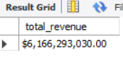

Average Order Size

SELECT AVG(quantity) FROM sales;
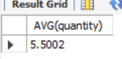

Top 5 selling products

SELECT p.product_name, SUM(s.quantity) AS units_sold
FROM sales s
JOIN products p USING(product_id)
GROUP BY product_name
ORDER BY units_sold
DESC LIMIT 5;
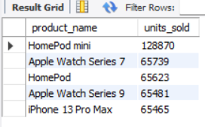

Most profitable category

SELECT c.category_name, SUM(s.quantity * p.price) AS revenue
FROM sales s
JOIN products p USING(product_id)
JOIN category c USING(category_id)
GROUP BY c.category_name
ORDER BY revenue DESC LIMIT 1;
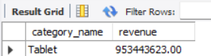

Yearly Sales Trend

SELECT YEAR(sale_date) AS year, SUM(quantity) as units_sold
FROM sales
GROUP BY year
order by year ;
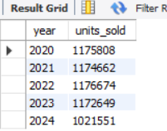

Sales Before vs After Product Launch

SELECT
p.product_name,
SUM(CASE WHEN s.sale_date < p.Launch_Date THEN quantity ELSE 0 END) AS before_launch,
SUM(CASE WHEN s.sale_date >= p.Launch_Date THEN quantity ELSE 0 END) AS after_launch
FROM sales s
JOIN products p USING(product_id)
GROUP BY p.product_name;

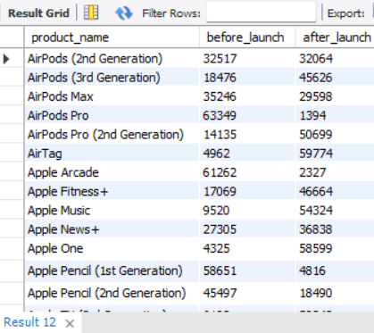

Store Distribution by Country

SELECT country, COUNT(*) AS total_stores
FROM stores
GROUP BY country;
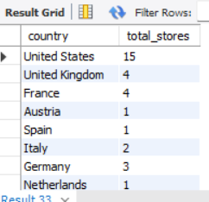

TOP 10 Country’s by Revenue

SELECT
st.Country,
SUM(s.quantity * p.Price) AS total_revenue
FROM sales s
JOIN products p ON s.product_id = p.Product_ID
JOIN stores st ON s.store_id = st.Store_ID
GROUP BY st.Country
ORDER BY total_revenue DESC;

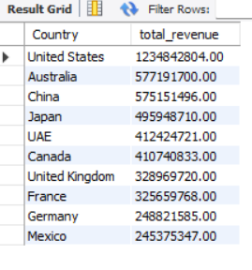

Products with high claims (bad quality)

SELECT p.product_name, COUNT(*) AS claims
FROM warranty w
JOIN sales s USING(sale_id)
JOIN products p USING(product_id)
GROUP BY p.product_name
ORDER BY claims DESC;
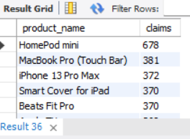

Pending vs Completed Status

SELECT repair_status, COUNT(*) AS count FROM warranty GROUP BY repair_status;

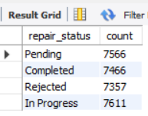

Warranty Claims Within X Days of Sale

SELECT
w.claim_id,
DATEDIFF(w.claim_date, s.sale_date) AS days_after_sale
FROM warranty w
JOIN sales s USING(sale_id);

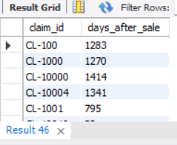

Creating Index

CREATE INDEX idx_sale_date ON sales(sale_date);
CREATE INDEX idx_product ON sales(product_id);
CREATE INDEX idx_store ON sales(store_id);

Testing index -
EXPLAIN SELECT * FROM sales WHERE product_id='P-48';

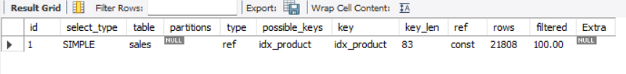

Views

CREATE VIEW sales_dashboard_view AS
SELECT
s.sale_date,
st.store_name,
p.product_name,
c.category_name,
s.quantity,
p.price,
(quantity * price) AS revenue
FROM sales s
JOIN products p USING(product_id)
JOIN category c USING(category_id)
JOIN stores st USING(store_id);

